网关模块LEN485-T拨码要设置为1

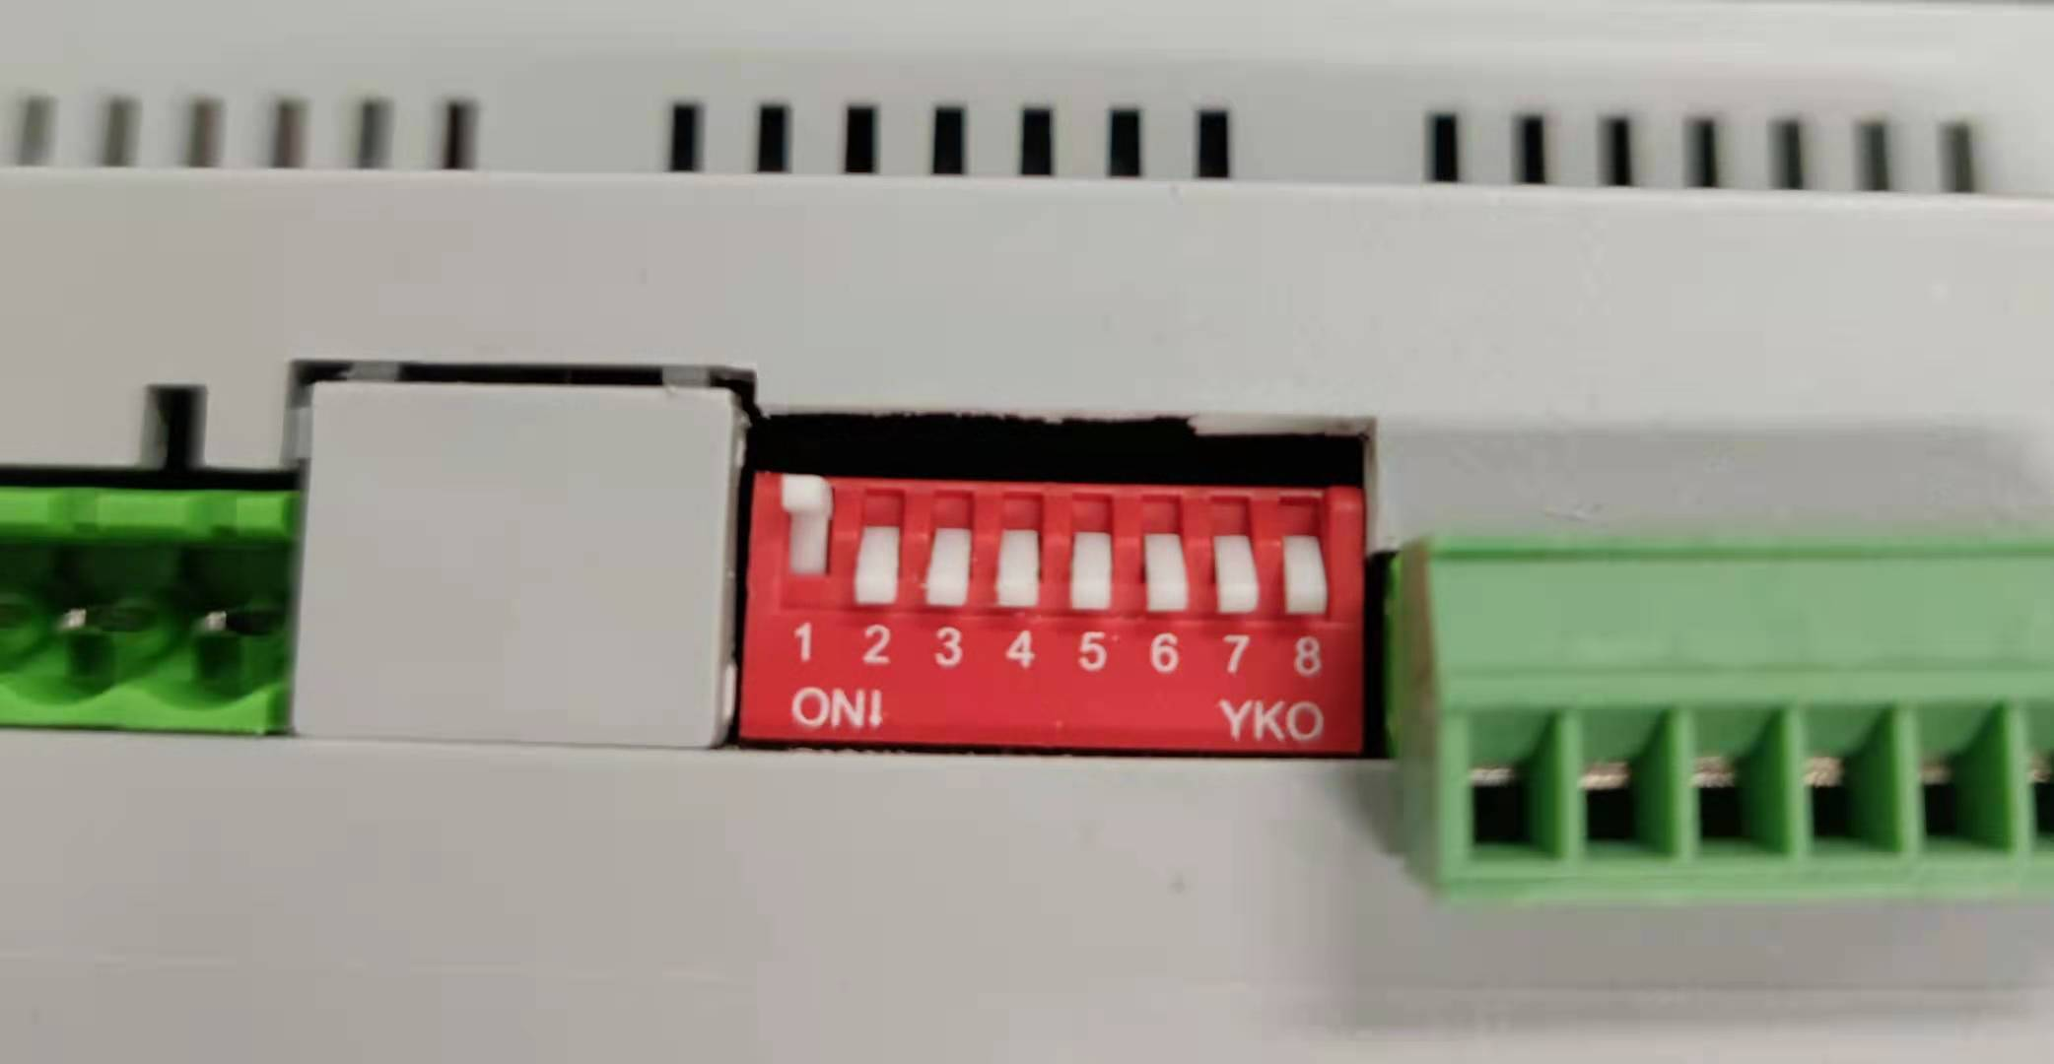

第1个12路开关模块LRC1220设置为0

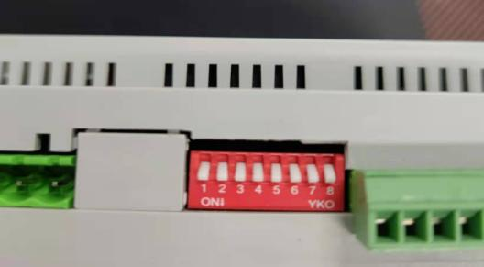

第2个12路开关模块LRC1220设置为1



Modbus协议

|  |  |
| --- | --- |
|  | 0号开关模块 |
| 第1回路开 | 00 00 00 00 00 06 01 06 00 00 00 01 |
| 第1回路关 | 00 00 00 00 00 06 01 06 00 00 00 00 |
| 第2回路开 | 00 00 00 00 00 06 01 06 00 01 00 01 |
| 第2回路关 | 00 00 00 00 00 06 01 06 00 01 00 00 |
| 第3回路开 | 00 00 00 00 00 06 01 06 00 02 00 01 |
| 第3回路关 | 00 00 00 00 00 06 01 06 00 02 00 00 |
| 第4回路开 | 00 00 00 00 00 06 01 06 00 03 00 01 |
| 第4回路关 | 00 00 00 00 00 06 01 06 00 03 00 00 |
| 第5回路开 | 00 00 00 00 00 06 01 06 00 04 00 01 |
| 第5回路关 | 00 00 00 00 00 06 01 06 00 04 00 00 |
| 第6回路开 | 00 00 00 00 00 06 01 06 00 05 00 01 |
| 第6回路关 | 00 00 00 00 00 06 01 06 00 05 00 00 |
| 第7回路开 | 00 00 00 00 00 06 01 06 00 06 00 01 |
| 第7回路关 | 00 00 00 00 00 06 01 06 00 06 00 00 |
| 第8回路开 | 00 00 00 00 00 06 01 06 00 07 00 01 |
| 第8回路关 | 00 00 00 00 00 06 01 06 00 07 00 00 |
| 第9回路开 | 00 00 00 00 00 06 01 06 00 08 00 01 |
| 第9回路关 | 00 00 00 00 00 06 01 06 00 08 00 00 |
| 第10回路开 | 00 00 00 00 00 06 01 06 00 09 00 01 |
| 第10回路关 | 00 00 00 00 00 06 01 06 00 09 00 00 |
| 第11回路开 | 00 00 00 00 00 06 01 06 00 0A 00 01 |
| 第11回路关 | 00 00 00 00 00 06 01 06 00 0A 00 00 |
| 第12回路开 | 00 00 00 00 00 06 01 06 00 0B 00 01 |
| 第12回路关 | 00 00 00 00 00 06 01 06 00 0B 00 00 |
| 全开 | 00 00 00 00 00 1F 01 10 00 00 00 0C 18 00 01 00 01 00 01 00 01 00 01 00 01 00 01 00 01 00 01 00 01 00 01 00 01 |
| 全关 | 00 00 00 00 00 1F 01 10 00 00 00 0C 18 00 00 00 00 00 00 00 00 00 00 00 00 00 00 00 00 00 00 00 00 00 00 00 00 |

|  |  |
| --- | --- |
|  | 1号开关模块 |
| 第1回路开 | 00 00 00 00 00 06 01 06 00 0C 00 01 |
| 第1回路关 | 00 00 00 00 00 06 01 06 00 0C 00 00 |
| 第2回路开 | 00 00 00 00 00 06 01 06 00 0D 00 01 |
| 第2回路关 | 00 00 00 00 00 06 01 06 00 0D 00 00 |
| 第3回路开 | 00 00 00 00 00 06 01 06 00 0E 00 01 |
| 第3回路关 | 00 00 00 00 00 06 01 06 00 0E 00 00 |
| 第4回路开 | 00 00 00 00 00 06 01 06 00 0F 00 01 |
| 第4回路关 | 00 00 00 00 00 06 01 06 00 0F 00 00 |
| 第5回路开 | 00 00 00 00 00 06 01 06 00 10 00 01 |
| 第5回路关 | 00 00 00 00 00 06 01 06 00 10 00 00 |
| 第6回路开 | 00 00 00 00 00 06 01 06 00 11 00 01 |
| 第6回路关 | 00 00 00 00 00 06 01 06 00 11 00 00 |
| 第7回路开 | 00 00 00 00 00 06 01 06 00 12 00 01 |
| 第7回路关 | 00 00 00 00 00 06 01 06 00 12 00 00 |
| 第8回路开 | 00 00 00 00 00 06 01 06 00 13 00 01 |
| 第8回路关 | 00 00 00 00 00 06 01 06 00 13 00 00 |
| 第9回路开 | 00 00 00 00 00 06 01 06 00 14 00 01 |
| 第9回路关 | 00 00 00 00 00 06 01 06 00 14 00 00 |
| 第10回路开 | 00 00 00 00 00 06 01 06 00 15 00 01 |
| 第10回路关 | 00 00 00 00 00 06 01 06 00 15 00 00 |
| 第11回路开 | 00 00 00 00 00 06 01 06 00 16 00 01 |
| 第11回路关 | 00 00 00 00 00 06 01 06 00 16 00 00 |
| 第12回路开 | 00 00 00 00 00 06 01 06 00 17 00 01 |
| 第12回路关 | 00 00 00 00 00 06 01 06 00 17 00 00 |
| 全开 | 00 00 00 00 00 1F 01 10 00 0C 00 0C 18 00 01 00 01 00 01 00 01 00 01 00 01 00 01 00 01 00 01 00 01 00 01 00 01 |
| 全关 | 00 00 00 00 00 1F 01 10 00 0C 00 0C 18 00 00 00 00 00 00 00 00 00 00 00 00 00 00 00 00 00 00 00 00 00 00 00 00 |